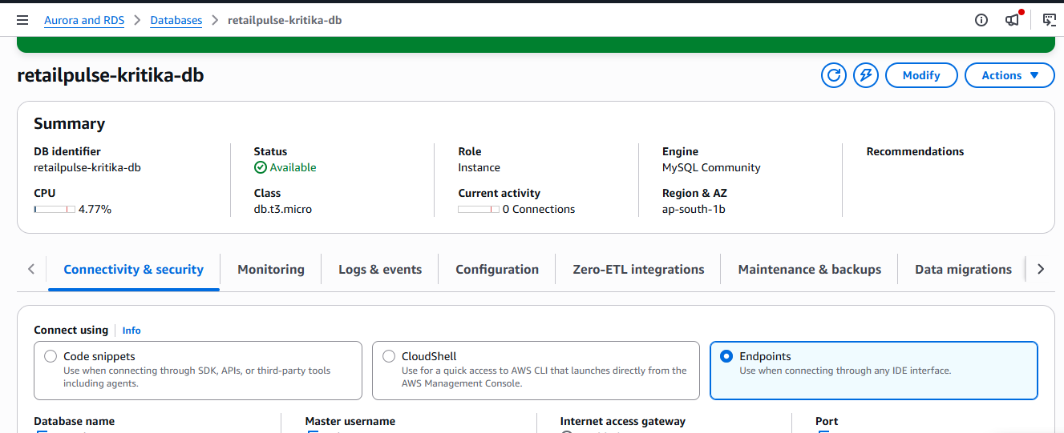

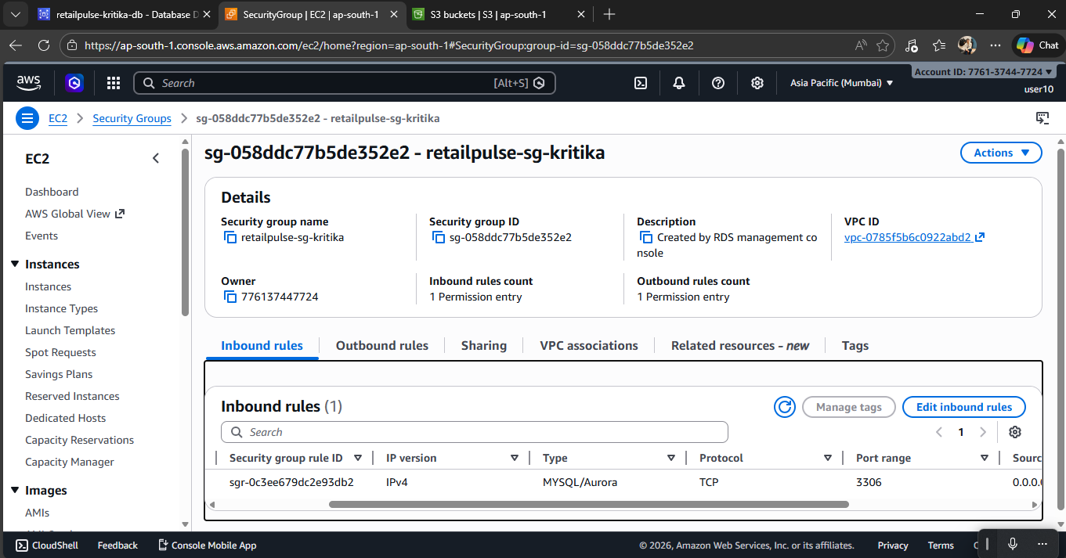

Now create an instance :

Loading the data to the ec2 instance:
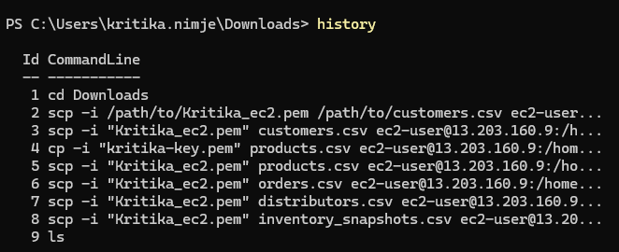

MySQL Command Execution Log – retailpulse_kritika
Environment: EC2 to RDS (MariaDB/MySQL)

Database Initialization
SHOW DATABASES;
CREATE DATABASE retailpulse_kritika;
USE retailpulse_kritika;
SELECT DATABASE();

Customers Table
CREATE TABLE customers (
customer_id VARCHAR(30),
registration_date DATE,
city VARCHAR(80),
state VARCHAR(50),
pincode VARCHAR(10),
customer_segment VARCHAR(20),
email_verified BOOLEAN,
phone_verified BOOLEAN,
loyalty_tier VARCHAR(15),
acquisition_channel VARCHAR(30),
date_of_birth DATE,
gender VARCHAR(10)
);

Products Table
CREATE TABLE products (
product_id VARCHAR(30),
product_name VARCHAR(200),
category VARCHAR(50),
sub_category VARCHAR(80),
brand VARCHAR(80),
base_mrp_inr DECIMAL(10,2),
cost_price_inr DECIMAL(10,2),
weight_kg DECIMAL(6,3),
is_active BOOLEAN,
launch_date DATE,
reorder_threshold INT,
return_window_days INT
);

Distributors Table
CREATE TABLE distributors (
distributor_id VARCHAR(20),
distributor_name VARCHAR(150),
region VARCHAR(30),
state VARCHAR(50),
city VARCHAR(80),
tier VARCHAR(15),
contact_email VARCHAR(100),
contact_phone VARCHAR(20),
is_active BOOLEAN,
onboarding_date DATE
);

Orders Table
CREATE TABLE orders (
order_id VARCHAR(40),
customer_id VARCHAR(30),
order_date DATETIME,
order_status VARCHAR(20),
product_id VARCHAR(30),
quantity INT,
unit_price_inr DECIMAL(10,2),
mrp_inr DECIMAL(10,2),
discount_code VARCHAR(20),
payment_method VARCHAR(20),
delivery_pincode VARCHAR(10),
distributor_id VARCHAR(20),
platform VARCHAR(15),
created_at DATETIME
);

Inventory Snapshots Table
CREATE TABLE inventory_snapshots (
snapshot_id VARCHAR(40),
snapshot_date DATE,
distributor_id VARCHAR(20),
product_id VARCHAR(30),
opening_stock INT,
units_received INT,
units_dispatched INT,
units_returned INT,
units_damaged INT,
closing_stock INT,
reorder_point INT
);

CSV Load Commands
LOAD DATA LOCAL INFILE '/home/ec2-user/customers.csv'
INTO TABLE customers
FIELDS TERMINATED BY ','
LINES TERMINATED BY '
'
IGNORE 1 ROWS;
LOAD DATA LOCAL INFILE '/home/ec2-user/products.csv'
INTO TABLE products
FIELDS TERMINATED BY ','
LINES TERMINATED BY '
'
IGNORE 1 ROWS;
LOAD DATA LOCAL INFILE '/home/ec2-user/distributors.csv'
INTO TABLE distributors
FIELDS TERMINATED BY ','
LINES TERMINATED BY '
'
IGNORE 1 ROWS;
LOAD DATA LOCAL INFILE '/home/ec2-user/orders.csv'
INTO TABLE orders
FIELDS TERMINATED BY ','
LINES TERMINATED BY '
'
IGNORE 1 ROWS;
LOAD DATA LOCAL INFILE '/home/ec2-user/inventory_snapshots.csv'
INTO TABLE inventory_snapshots
FIELDS TERMINATED BY ','
LINES TERMINATED BY '
'
IGNORE 1 ROWS;

Verification Queries
SELECT COUNT(*) FROM customers;
SELECT COUNT(*) FROM products;
SELECT COUNT(*) FROM orders;
SELECT COUNT(*) FROM distributors;
SELECT COUNT(*) FROM inventory_snapshots;
SELECT * FROM orders WHERE order_id IS NULL;
SELECT * FROM products WHERE cost_price_inr <= 0;
SELECT * FROM inventory_snapshots WHERE closing_stock < 0;

STEP 3 – Data Validation Queries & Results (RetailPulse)
Database: retailpulse_kritika
Environment: EC2 → RDS (MySQL/MariaDB)
This document contains ALL validation queries executed during STEP 3, exactly as run in MySQL, along with their purpose.

1. Customers – Data Quality Validation
SELECT * FROM customers WHERE customer_id IS NULL;
SELECT customer_id, COUNT(*) FROM customers GROUP BY customer_id HAVING COUNT(*) > 1;
SELECT * FROM customers WHERE state IS NULL;

2. Products – Pricing & Inventory Rules
SELECT * FROM products WHERE cost_price_inr <= 0;
SELECT * FROM products WHERE reorder_threshold < 0;
SELECT product_id, COUNT(*) FROM products GROUP BY product_id HAVING COUNT(*) > 1;

3. Orders – Transaction Integrity (CRITICAL)
SELECT * FROM orders WHERE order_id IS NULL;
SELECT * FROM orders WHERE order_date > NOW();
SELECT * FROM orders o LEFT JOIN customers c ON o.customer_id = c.customer_id WHERE c.customer_id IS NULL;
SELECT * FROM orders WHERE order_status = 'RETURNED' AND order_id NOT IN (SELECT order_id FROM orders WHERE order_status = 'DELIVERED');
SELECT * FROM orders WHERE unit_price_inr > mrp_inr;
SELECT o.* FROM orders o JOIN products p ON o.product_id = p.product_id WHERE o.unit_price_inr < p.cost_price_inr;
SELECT * FROM orders WHERE delivery_pincode NOT REGEXP '^[1-9][0-9]{5}$';
SELECT order_id, COUNT(*) FROM orders GROUP BY order_id HAVING COUNT(*) > 1;

4. Inventory Snapshots – Stock & Alert Engine
SELECT * FROM inventory_snapshots WHERE closing_stock < 0;
SELECT * FROM inventory_snapshots WHERE closing_stock != (opening_stock + units_received - units_dispatched + units_returned - units_damaged);
SELECT * FROM inventory_snapshots WHERE closing_stock = 0;
SELECT * FROM inventory_snapshots WHERE closing_stock < reorder_point;

5. Conclusion
-- All above queries returned expected faulty records
-- Data quality rules, pricing rules, lifecycle rules, and inventory alert logic verified
-- System ready for STEP 4: Transformations & Clean/Invalid Data Routing

STEP 4 – Data Cleaning & Transformation Queries
Database: retailpulse_kritika
Environment: EC2 → RDS (MySQL / MariaDB)
Purpose: Separate clean vs invalid data and generate inventory alerts without overwriting raw tables.

4.1 Customers Cleaning
CREATE TABLE customers_clean AS SELECT * FROM customers WHERE customer_id IS NOT NULL AND state IS NOT NULL;
CREATE TABLE customers_invalid AS SELECT * FROM customers WHERE customer_id IS NULL OR state IS NULL;
SELECT COUNT(*) FROM customers_clean;
SELECT COUNT(*) FROM customers_invalid;

4.2 Products Cleaning
CREATE TABLE products_clean AS SELECT * FROM products WHERE cost_price_inr > 0 AND reorder_threshold >= 0;
CREATE TABLE products_invalid AS SELECT * FROM products WHERE cost_price_inr <= 0 OR reorder_threshold < 0;
SELECT COUNT(*) FROM products_clean;
SELECT COUNT(*) FROM products_invalid;

4.3 Orders Cleaning (Critical)
CREATE TABLE orders_clean AS SELECT o.* FROM orders o JOIN customers_clean c ON o.customer_id = c.customer_id JOIN products_clean p ON o.product_id = p.product_id WHERE o.order_id IS NOT NULL AND o.order_date <= NOW() AND o.unit_price_inr <= o.mrp_inr AND o.delivery_pincode REGEXP '^[1-9][0-9]{5}$';
CREATE TABLE orders_invalid AS SELECT * FROM orders WHERE order_id IS NULL OR order_date > NOW() OR unit_price_inr > mrp_inr OR delivery_pincode NOT REGEXP '^[1-9][0-9]{5}$';
SELECT COUNT(*) FROM orders_clean;
SELECT COUNT(*) FROM orders_invalid;

4.4 Inventory Cleaning
CREATE TABLE inventory_clean AS SELECT * FROM inventory_snapshots WHERE closing_stock >= 0 AND closing_stock = (opening_stock + units_received - units_dispatched + units_returned - units_damaged);
CREATE TABLE inventory_invalid AS SELECT * FROM inventory_snapshots WHERE closing_stock < 0 OR closing_stock != (opening_stock + units_received - units_dispatched + units_returned - units_damaged);
SELECT COUNT(*) FROM inventory_clean;
SELECT COUNT(*) FROM inventory_invalid;

4.5 Inventory Alert Generation
CREATE TABLE inventory_alerts AS SELECT distributor_id, product_id, closing_stock, reorder_point, CASE WHEN closing_stock = 0 THEN 'CRITICAL' WHEN closing_stock < reorder_point THEN 'LOW_STOCK' ELSE 'OK' END AS alert_type FROM inventory_clean;
SELECT * FROM inventory_alerts WHERE alert_type != 'OK';

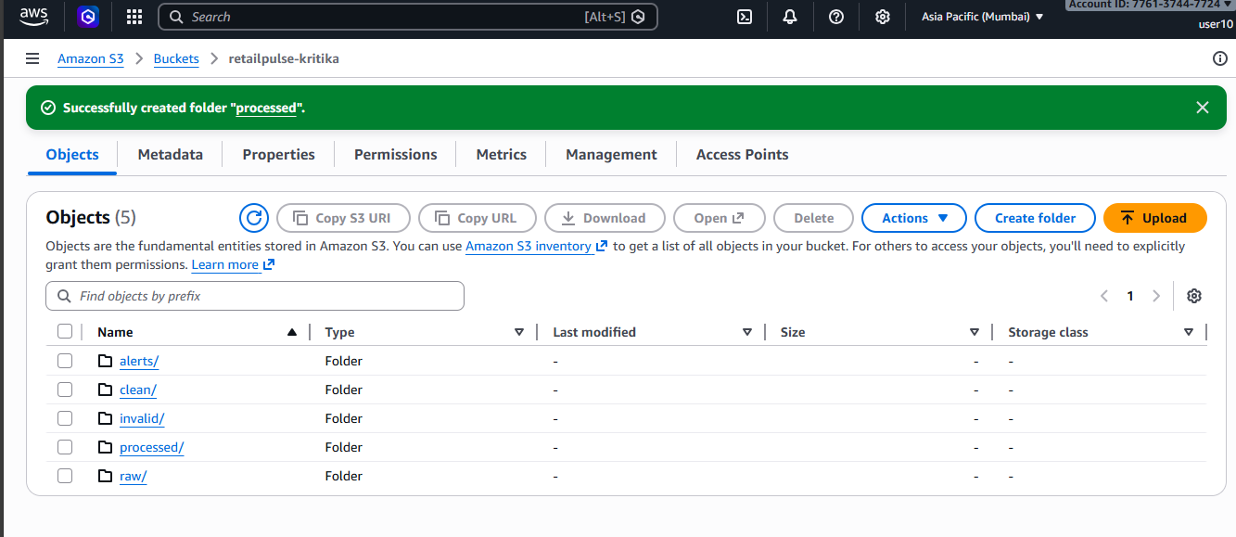

from pyspark.sql import SparkSession
from pyspark.sql.functions import col, when, current_date, to_timestamp

def main():

spark = SparkSession.builder \
.appName("RetailPulseETL_Kritika") \
.getOrCreate()

# =========================
# 1. READ FROM S3 JSON
# =========================
df_json = (
spark.read
.option("multiLine", "true") # JSON is array
.option("mode", "PERMISSIVE")
.option("columnNameOfCorruptRecord", "_corrupt_record")
.json("s3://retailpulse-kritika/raw/orders_events.json")
)

print("Schema:")
df_json.printSchema()

# =========================
# 2. HANDLE CORRUPT RECORDS
# =========================
if "_corrupt_record" in df_json.columns:
df_json_good = df_json.filter(col("_corrupt_record").isNull())
df_json_bad = df_json.filter(col("_corrupt_record").isNotNull())

# Store bad records in quarantine
df_json_bad.write \
.mode("overwrite") \
.parquet("s3://retailpulse-kritika/quarantine/raw_orders/")

else:
df_json_good = df_json

# =========================
# 3. BASIC CLEANING + STANDARDIZATION
# =========================
df_clean = df_json_good.select(
col("event_id"),
col("order_id"),
col("event_type"),
to_timestamp(col("event_timestamp")).alias("event_time"),
col("customer_id"),
col("product_id"),
col("quantity").cast("int"),
col("status")
)

# =========================
# 4. VALIDATIONS
# =========================
valid_condition = (
(col("order_id").isNotNull()) &
(col("event_time") <= current_date())
)

df_valid = df_clean.filter(valid_condition)
df_quarantine = df_clean.filter(~valid_condition)

# =========================
# 5. ENRICHMENT
# =========================
df_enriched = df_valid.withColumn(
"order_size",
when(col("quantity") >= 5, "BULK")
.when(col("quantity") >= 2, "MEDIUM")
.otherwise("SMALL")
)

# =========================
# 6. FILTER SUCCESS EVENTS
# =========================
df_final = df_enriched.filter(col("status") == "SUCCESS")

# =========================
# 7. WRITE PROCESSED DATA
# =========================
df_final.write \
.mode("overwrite") \
.parquet("s3://retailpulse-kritika/processed/orders/")

# =========================
# 8. WRITE FAILED VALIDATION
# =========================
df_quarantine.write \
.mode("overwrite") \
.parquet("s3://retailpulse-kritika/quarantine/invalid_orders/")

spark.stop()

if __name__ == "__main__":
main()

